# Web Foundation Year 2

# UP633808: Student Logbook 2012/13

# CONTENTS

1. Where things are p3
2. Mindmap/spider diagram p4
3. Exercises p5

Ex 1 Template p7

Ex 2 Redesign p8

Ex 3 Validation p9

Ex 4 CSS Styling p10

Ex 5 Planning the site p12

* Your target audience p13
* Competitor research p14
* Sitemap p16
* Client Requirements p17
* Wireframe p18
* Researched artist sites p19

Ex 6 Site Outline p25

Ex 7 Initial validation p26

Ex 8 Cookie policy p27

Ex 9 Initial SEO p28

Ex 10 XML sitemap p38

Ex 11 Contact form p40

Ex 12 Peer review p41

Ex 13 SEO Report p43

Ex 14 Demonstration p44

Ex 15 Final Logbook Handin p45

4. References p46

# Where things are

The location of the Web f2 Coursework and Templates, is found on the K drive.

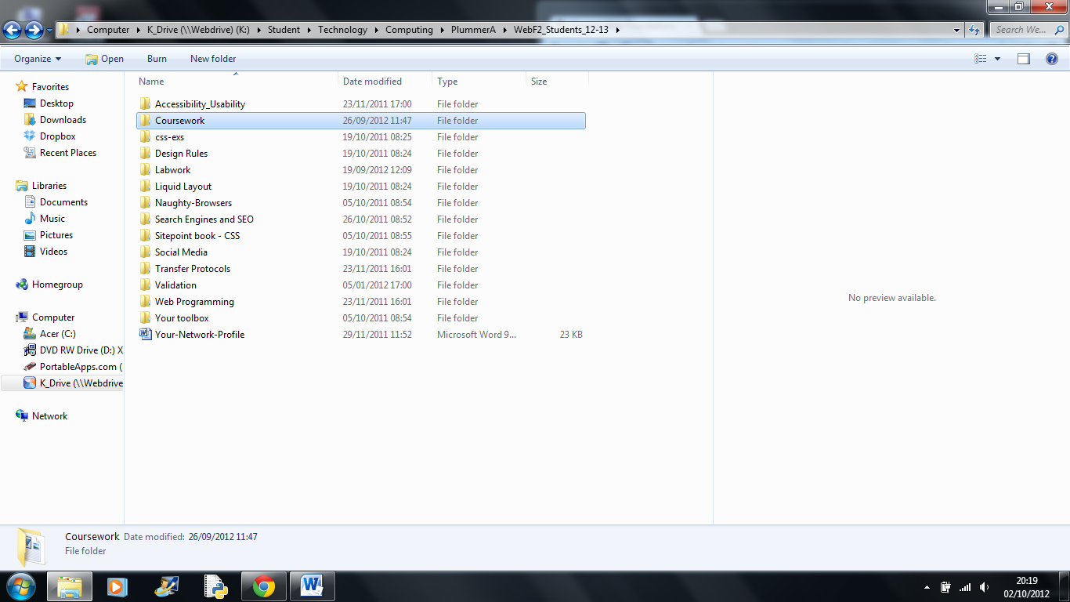

# Mindmap/Spider Diagram

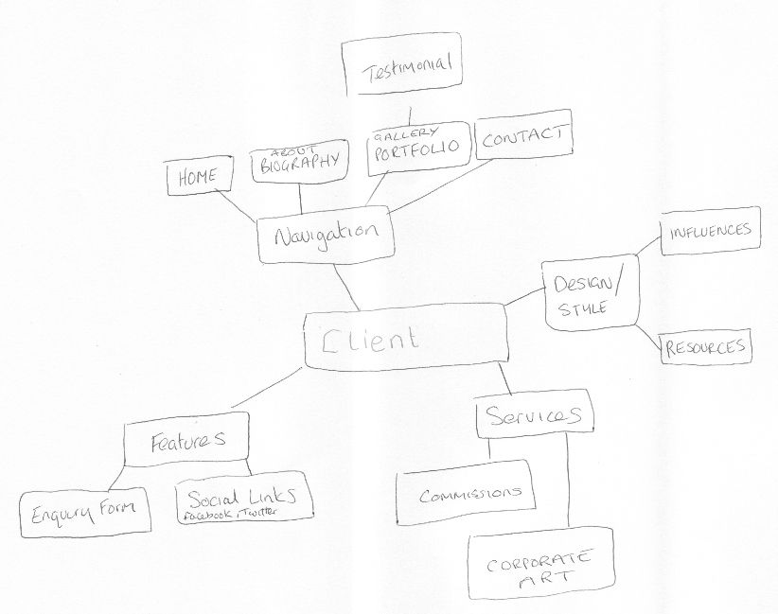

# Excercises

# Introduction

# WebF2 is 60% assessed by examination.

The remainder (40%) is logbook exercises.

# Format – no logbook will be accepted if it does not adhere to this format.

* **Floppy RINGBINDER** only please (so pages can be added / removed).
* No plastic wallets.
* You should have some sort of index at the front.
* Your name / ID should be clearly marked on every page.
* You may use handwritten entries or type them in, or a mixture of both.
* It is your responsibility to keep it updated, checked and signed off regularly.
* I strongly suggest you back your logbook up regularly!

# What's a 'suitable' logbook?

1. Checked and signed off regularly (there will be no time to check it thoroughly and sign it off at the last minute). Under no circumstances will your logbook get more than one signoff per session.
2. In the correct format.
3. Ensure you get the receipt sheet regularly signed, along with the logbook pages.
4. Be prepared to answer questions about your work. You will get far more credit answering questions confidently about a fairly basic piece of work than struggling to answer questions about something that looks incredible and might not be your own . . .

# About the Exercises

This is a rough guide – web design is as much an art as a science and as such should not be prescriptive, so your creativity and exploration of each area are very important. There are (obviously) various rules you will need to follow, but often you will find yourself exploring an area that grabs your imagination and perhaps developing it within your project.

Web site creation involves turning a site concept, whether a sketch or an electronic plan (eg Photoshop), into a finished web site.

It involves several skill areas including graphics optimisation, XHTML/HTML5, CSS, JavaScript, perhaps some server-side scripting, accessibility, and SEO (search engine optimisation).

Taking a page design and making it into a living, breathing web page involves hundreds of decisions. What you choose to do will depend on your knowledge, experience, tools, and time.

You do not have to stick with the exact order but I suggest you don't deviate too much.

You will be creating sites to work X-browser, but I suggest you design/code with Firefox in mind, then worry about tweaking it for unruly browsers (like IE, though even that is improving).

# Exercises

The first few exercises are to get you used to the tools you will be using. Some of you will have been working on sites all summer and some of you won't have put a site together for some time.

1. You will find a folder called 'Template'. This is a simple, 2-column layout; *index.html*, *style.css*. It has very little styling, apart from column 2 being fluid (left column is static). You will be using this initially to develop some necessary skills. You may continue developing this or create your own from scratch. View the site in a browser:

You'll notice that it's not terribly exciting {:o) – it also does not validate. It has no top banner or footer, no graphics . . . but the 2nd column *is* fluid:

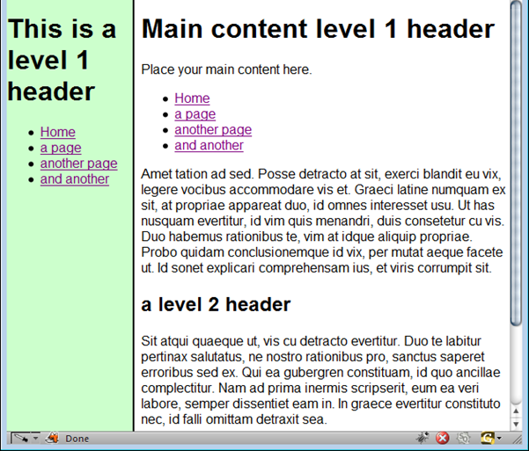

Open the site in Komodo and indent the XHTML sensibly. *Why bother?*

Answer this question in your log.

A: Indenting is important because it makes your code easy to read for yourself and fellow coders who may have to work on your project.

Now open the folder/learning module called 'Validation' and read through 'Doctypes.doc'.

Change the doctype to strict or go with the HTML5 doctype (see <http://www.webmonkey.com/2010/02/building_web_pages_with_html_5/> ) if you're not sure.

Why would you want to change the doctype? (it *will* give you more work).

A: Initially, so the page validates but also to declare your mark up is html5.

1. Create a header (banner) section and a footer. Put screenshots of the results in your log, along with short notes.

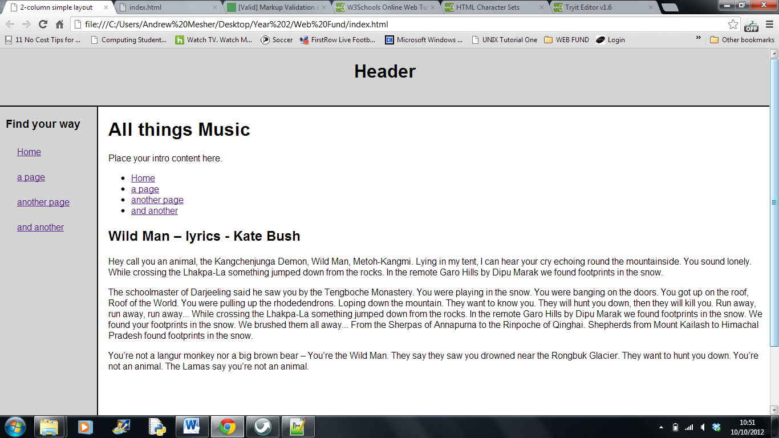

1. Using SGML parser (or the Google one, built into Chrome), validate your site. Make notes on every error and how you fixed it.

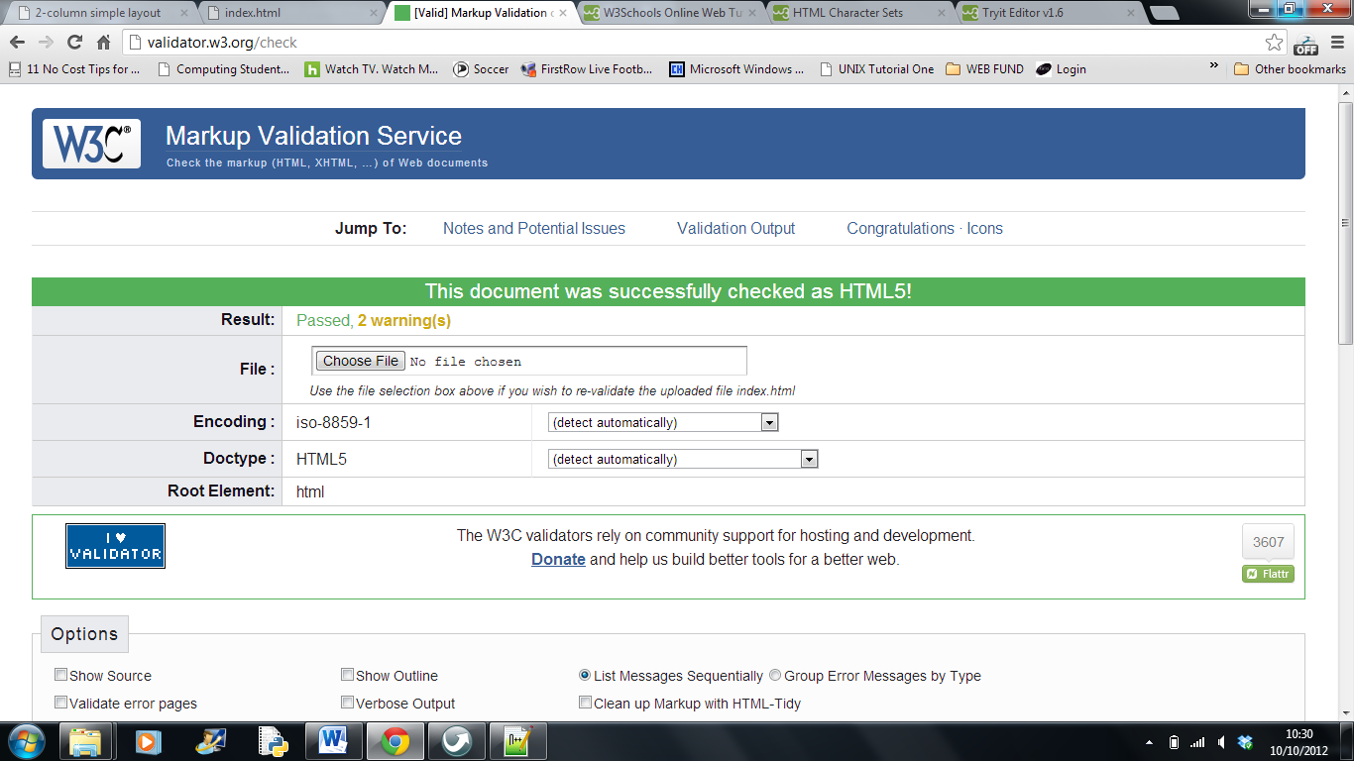

* *Line 7, Column 30*: Duplicate attribute topmargin.

<body topmargin="0" topmargin**=**"0">

Result: removed topmargin=”0”>

* *Line 7, Column 34*: Attribute topmargin not allowed on element body at this point.

<body topmargin="0" topmargin="0"**>**

Result: removed topmargin=”0”>

* *Line 35, Column 14*: No explicit character encoding declaration has been seen yet (assumed windows-1252) but the document contains non-ASCII.

<h2>Wild Man **–** lyrics - Kate Bush</h2>

Result: Code from W3C Schools –

<meta http-equiv="Content-Type"

content="text/html;charset=ISO-8859-1">

1. Improve the look of your navigation. Do this purely in CSS. Make notes on your decisions.

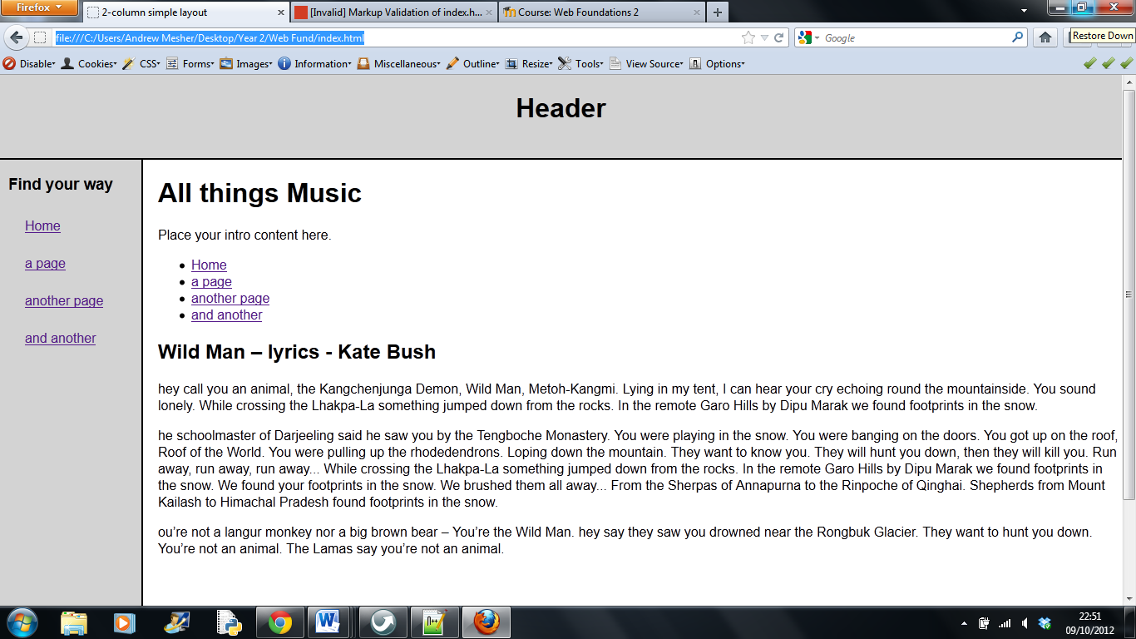

* Minimal styling used – changed head/foot and nav to a light grey colour
* Reduced size of nav header, so it didn’t break over two lines
* Added a hover feature in the nav to change colour
* Put some air into the nav area

The rest of the logbook is to follow. You will need a site to work on for BOTH terms, so find yourself a client. There are many small businesses out there who won't say 'no' to a free website. Do you know a band who would appreciate a site? A charity shop? Family restaurant? Author? Church? Local society or group? etc …....

# Project

You will by now have a project and a user.

Either continue developing the template site or create one from scratch.

5. Plan the site in your logbook – an outline sketch to start is fine, but it should give an indication of divs, padding, colour, font stacks, graphics, page names, SEO considerations, forms, etc. Follow *planning-your-site.doc*.

# 5. Planning the Site

# What is Your Website About?

A project with the aim to assist a local artist in the development of an online portfolio, to market her work and attract a corporate and commission based clientele.

Mission Statement:

“*To create inspiring artwork for view by the public and private realm”*

# Your Market

l **Demographic:** Age: 35 approx. to 65 approx.  
 Marital Status: Single and married  
 Sex: Male and Female  
 Ethnicity: Creative Arts/Media, designers, architects.  
 Occupation: Professionals  
 Dwelling: Home Owner

l **Geographic:**  UK mainland, possibly worldwide.

l **Behavioural:** Corporate art based works to include commercial spaces. Commissioned work on request for bespoke private projects.

l **Psychographic:** The artist has an established interest in Interior Design and Architecture. The paintings represent the historic layers revealed around buildings and interiors that have been stripped back, to reveal the art of palimpsest.

# Your Target Audience

Your target audience should dictate:

* Tone of voice – influential, inspiring, feel good

* Where you advertise – n/a

* Navigation - ????

* Services offered – painting by commission or online enquiries

* Prices – individually set by the artist

* Products Sold – bespoke artwork only

* Method of contact – business email only

* Colours used – mainly white to give maximum attention to artwork. Also, greys to break up the monotony of black type.

* How you advertise – word of mouth, social network, recognition within the industry

* Your logo – clients signature

* Depth of content –

* Everything -

# Competitor research

Unless you are first to market you will be competing with other websites. To avoid reinventing the wheel take advantage of their hard work and have a look at what they have done and sign up to any newsletters / marketing emails they have.

l How have they structured their website?  
There is a common theme with artist sites and that is to attract the users’ attention to the artwork. There are few distractions’; the colours used are minimal and light. Emphasis of the paintings is followed by the artists logo, which tend to be the artists name. The navigation usually consists of the Home page, Biography, Gallery, Press Alerts and Contact details.

l What tone of voice do they use?  
The tone set is subtle and welcoming and immediately catches the users’ attention, forcing them to make an opinion of the artwork.

l What services / extras do they offer?  
Mainly commissioned based services. Advertising of events and press critiques.

l What can you do differently / better?  
The use of social network sites to advertise the artist’s news, thoughts and current activities. Including influences, suggestions on current commissions, promotions and sales. Supply artwork for retail outlets.

l What are their product features / prices?   
Not advertised but occasionally priced according to the artists status.

l How do they promote themselves (new and existing visitors / customers)?  
Through status/reputation and online search engines and industry periodicals.

Note: This isn’t to suggest you should copy any design work or web copy; just take inspiration from what is good and fill any gaps you see.

To see how active they are marketing themselves and gaining brand exposure use Google’s web search, news search and blog search. To find out which sites are linking to them there are many tools you can use.

Bing's is in with its webmaster toolbox: <http://www.bing.com/toolbox/webmaster>

It is also worth looking at their metadescription and meta-keywords. Although they no longer really influence the large search engines, some sites still add them (and it doesn't hurt to be safe, rather than sorry ...). From this you can see which keywords they think are the most important and then use that information on your own site. You should also be trawling through the Adwords research tool results: <https://adwords.google.co.uk/o/Targeting/Explorer?__u=1000000000&__c=1000000000&ideaRequestType=KEYWORD_IDEAS#search.none>

# Search results

Conduct a series of searches using your market’s core search terms (you should brainstorm key search phrases with your client):

l Which sites are ranked highest organically?  
Using the search term artist; [www.tate.org.uk](http://www.tate.org.uk) came out on top

l Which sites are advertising using PPC?  
ebay.co.uk and ask.com

l Are any user feedback / comments ranked highly and what do they say?  
n/a

l Who are the big directories / forums / blogs in your market?  
[www.artistsandillustrators.co.uk](http://www.artistsandillustrators.co.uk), [www.artweb.com](http://www.artweb.com), www.a-n.co.uk/

# Forums, blogs & niche social networks

Have a look around the social media sites that cater for your target audience and see what people are saying about their current providers, both positive and negative (e.g. “I wish they gave me xyz as well” or “Mine has been so quick in responding to me”). From this you can see where the gaps are and what people consider to be important.

The type of information being fed on the social networks, are discussing the artists paintings and events. Mainly comments regarding technical details of how the artist achieved the final artwork.

# Choosing a Domain Name

The sooner you get this the better! It needs to get out there and start climbing out of the Google sandbox ASAP!

If you possibly can, choose one that has a key search phrase in it, eg yumyum-*chinese-restaurant-Godalming.co.uk* gets the name of the business in there + a descriptive phrase + a town name + it's not too difficult to remember. Bear in mind, Google’s EMD (exact Match Domains) Algo update: <http://www.seomoz.org/blog/googles-emd-algo-update-early-data>

# Draw a site map

One of the most frustrating experiences is to hand code your navigation’s menu and copy that across the entire site only to find you need to add another page and link. After updating all the menu’s you find yet another page is required and you have to go back through it all again (and again...).

A little bit of planning up front will become a major time save further down the line so before you dive in to coding your site sit down with a pen and a paper and draw out how each page links to the others. Here's a free tool: <http://writemaps.com/>

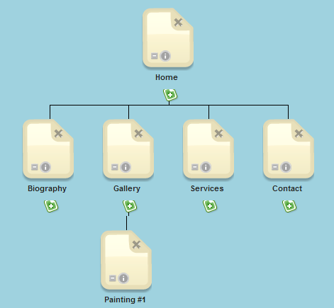

# Wire framing

Once you have done this the next step is to ‘wire frame’ your pages. Here you forgo any thoughts about the design (colour, icons, font formatting etc.) and piece together the basic layout and purpose of each page.

Following this process may seem a bit boring and tedious but because you have already visualised how the page elements sit together you can prevent any unnecessary (and painful) changes further down the line where you hit a brick wall and have to come back to start again. This should be agreed with your user.

Don’t forget to refer to the MindMap for any other design links that may help you (+ the *Essential Tools for WebF.doc* helpsheet)

# The Details

You need to get thorough now – What colours, fonts, graphics, pages, etc. have you agreed with your user? Have they got a logo? Will you be designing it for them?

**Fonts**: Here are a few suggested fonts that the client has seen. No decision has been made as yet, however the client is keen for me to make the overall decision. For the logo either Lato or Ubuntu both found on Google Web Fonts.  
For the body possibly PT Sans/Serif, Aller or Opensans.

**Colours**: To be minimalist, making the most of the white space. Headings in a grey tint.

**Graphics**: Very plain and subtle, no shading or gradients.

**Pages**: All to be consistent with each other with only the body content changing.   
The gallery page must not be flash based or anything too striking.

**Logo**: To be the artists name. The client has asked me to source a suitable font.

What features will be on the site? Blog? Forum? CMS? Shop? Contact Forms? Embeds? Slideshow? Etc.

**Features**: The client has requested a gallery. There won’t be a slideshow however, a painting will enlarge on selection and you will be manually able to move onto the next piece of artwork.

Contact to the client will be via email as requested by the client.

Client refuse the offer of a blog and forum. It was also stated that the website is not a shop and therefore payment of any item will be done separate to the site.

What languages are you going to use?   
PHP, HTML5 and CSS.

What are you agreeing to, re maintenance?  
It has been agreed that I will maintain the site and continue updating on clients request.

Draw a detailed design for every page you have already wireframed. Your client will need to sign this off (you don't want the scope slipping – that's a lot of extra work).

**Get your logbook signed.**

**Wireframe**

UK Online contemporary artists

The purpose is to research three current artist sites and get a feel for how the site exhibits the artwork. It is essential to design a stage that shows off the artists’ work in the best possible manner.

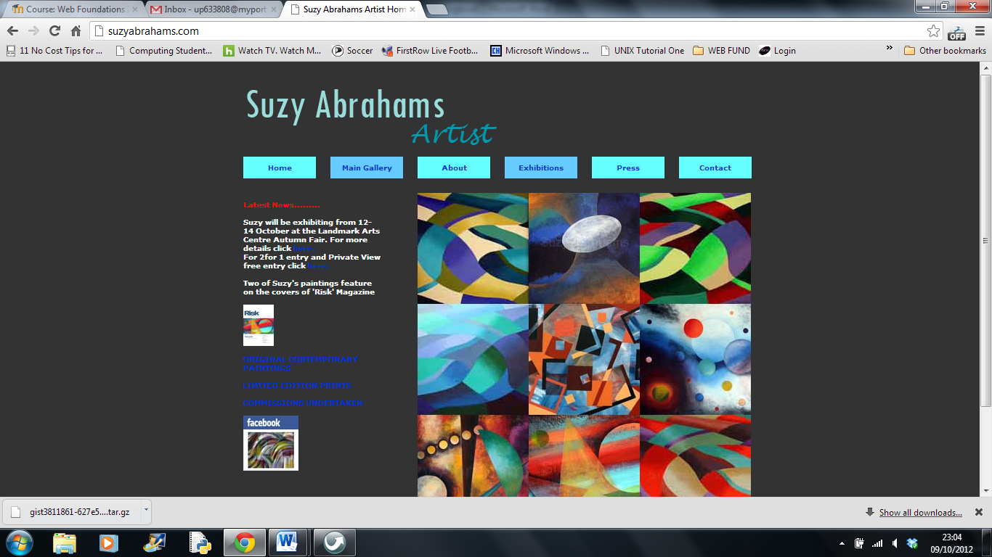

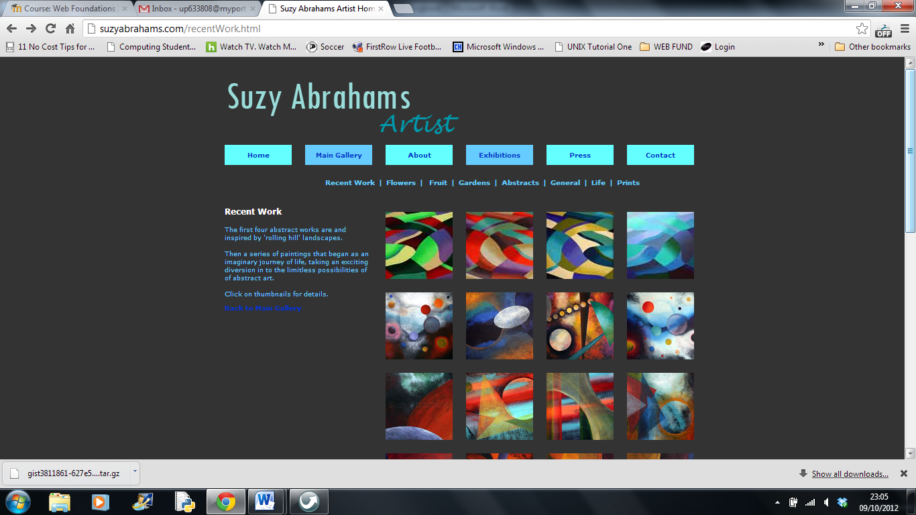

UK Online contemporary artists

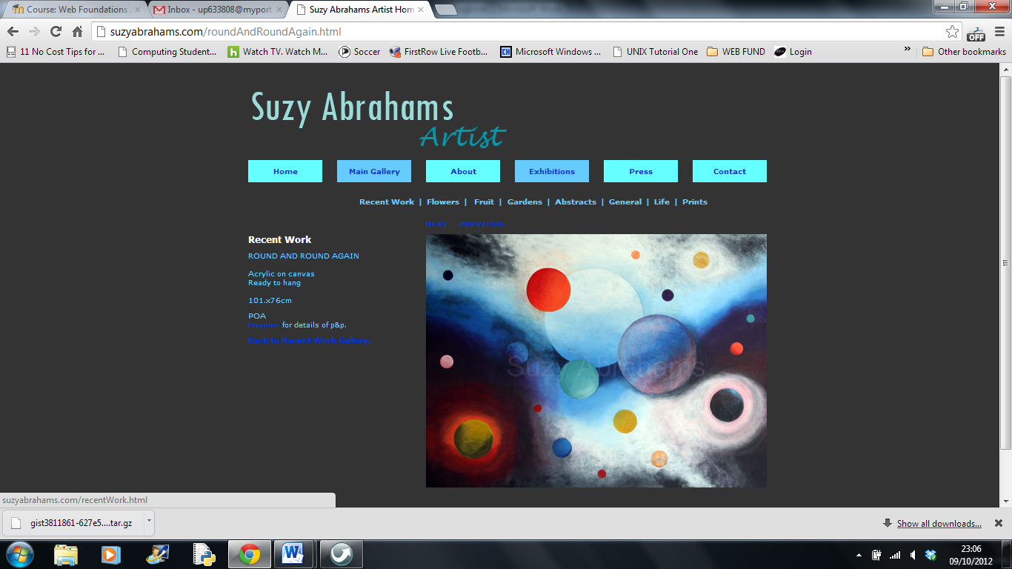

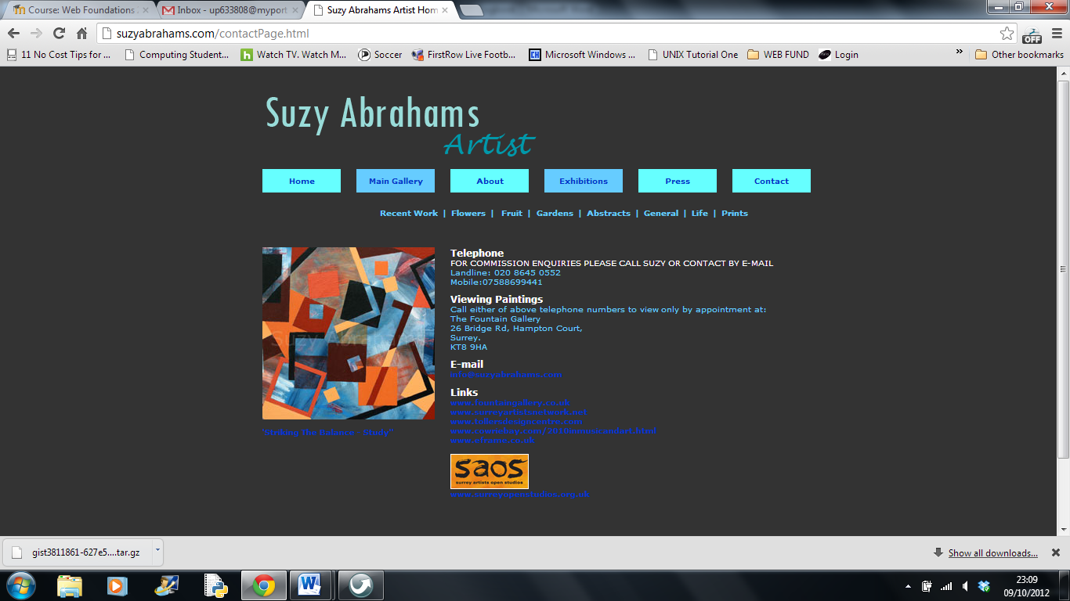

UK Online contemporary artists

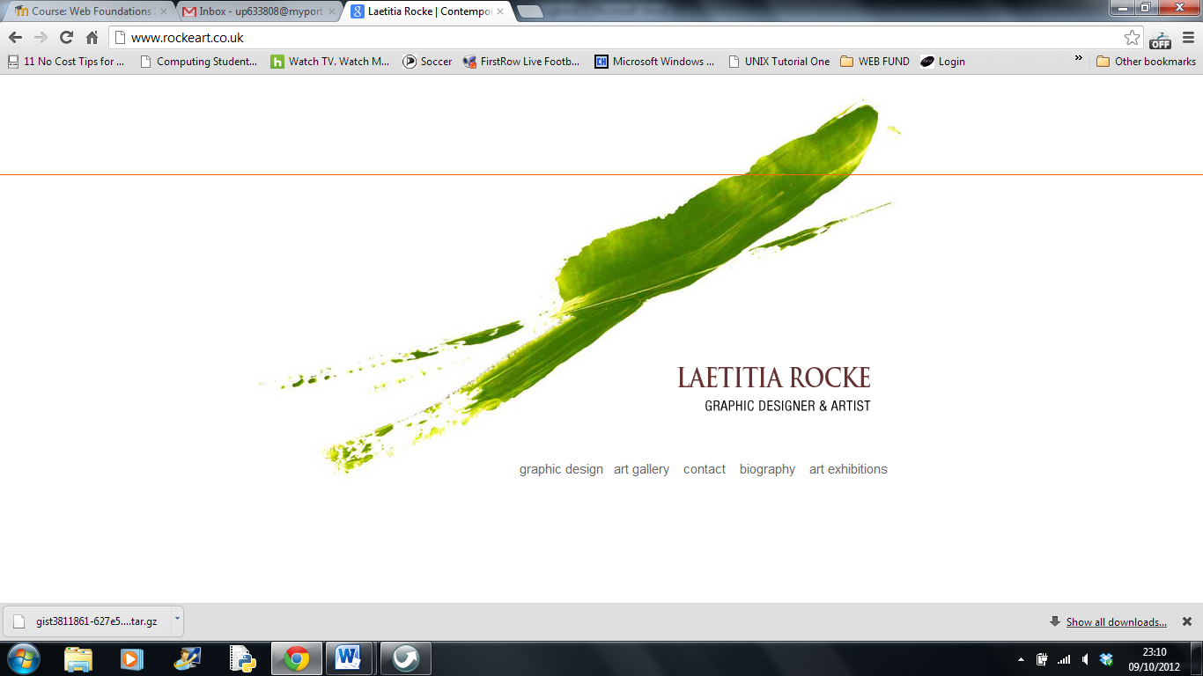

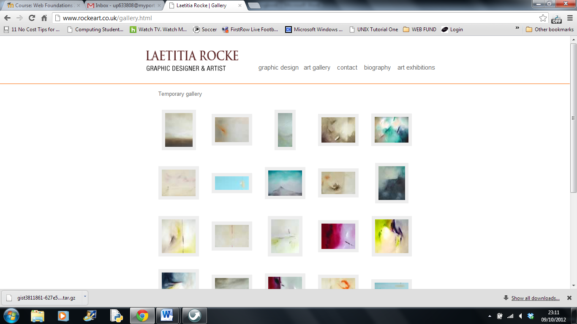

UK Online contemporary artists

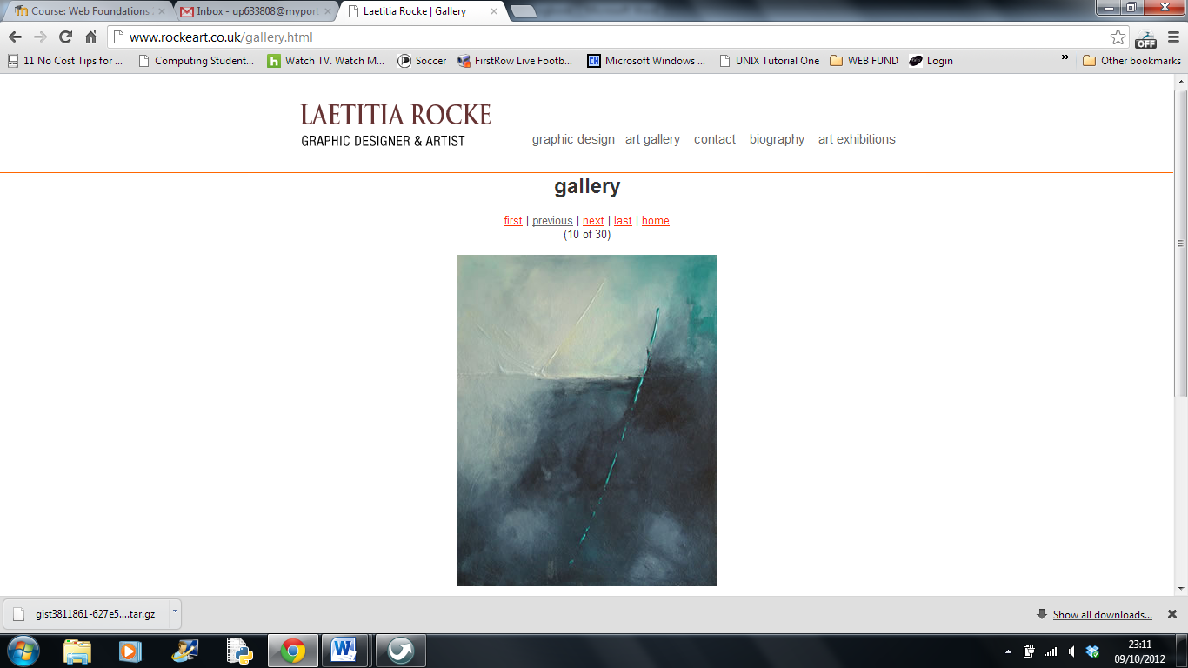

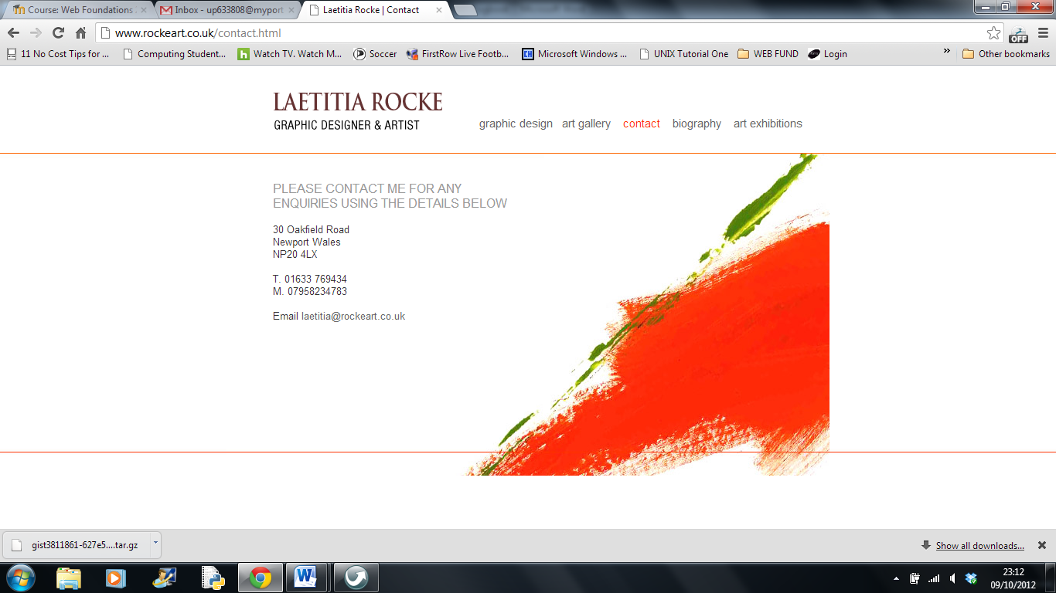

UK Online contemporary artists

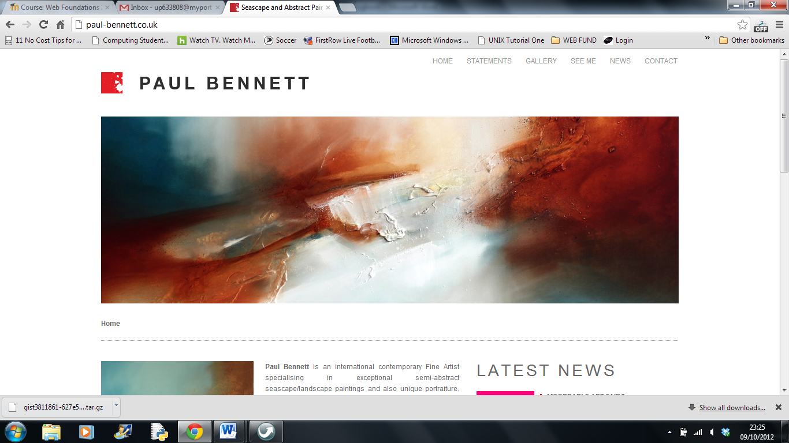

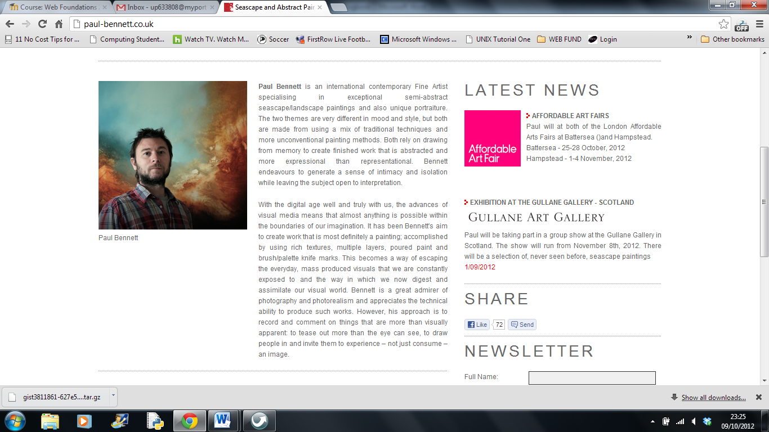

UK Online contemporary artists

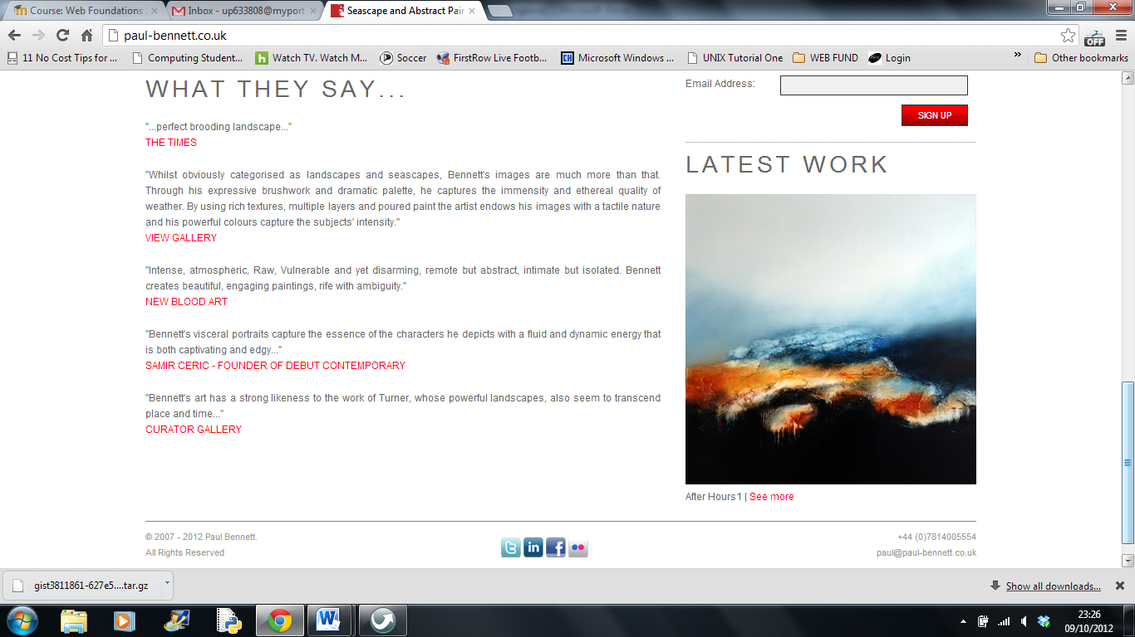

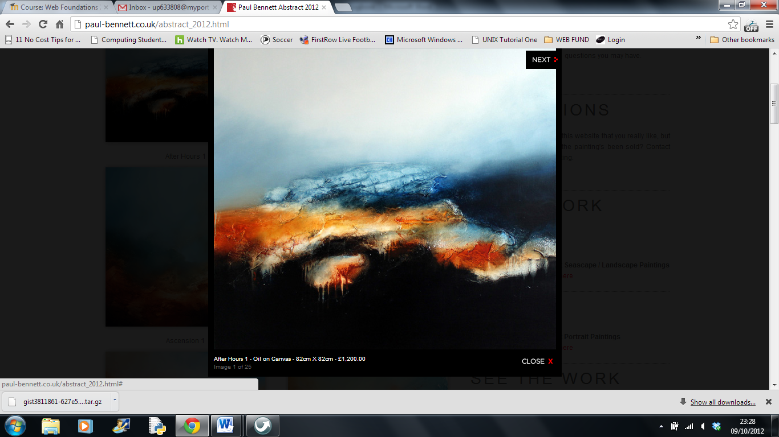

6. Build an outline site to upload (don't worry about it being very unfinished, it's just important to wave the new site at the search engines ASAP to see SEO results). Ensure you have outline pages for all your content. Using <http://www.000webhost.com/> or similar, upload your site to the Internet. You can either use the default URL they provide or you can select a free domain, eg <http://www.freedomain.co.nr/>. You should use an FTP program such as CuteFTP or similar to upload your site. See *Essential tools for Webf.doc* for free tools. You will continue to re-upload material as you develop the site.

- test your site in all the major browsers and back versions of IE. Make notes on any problems and how you got round them. You may find the contents of *Naughty-Browsers* folder of use.

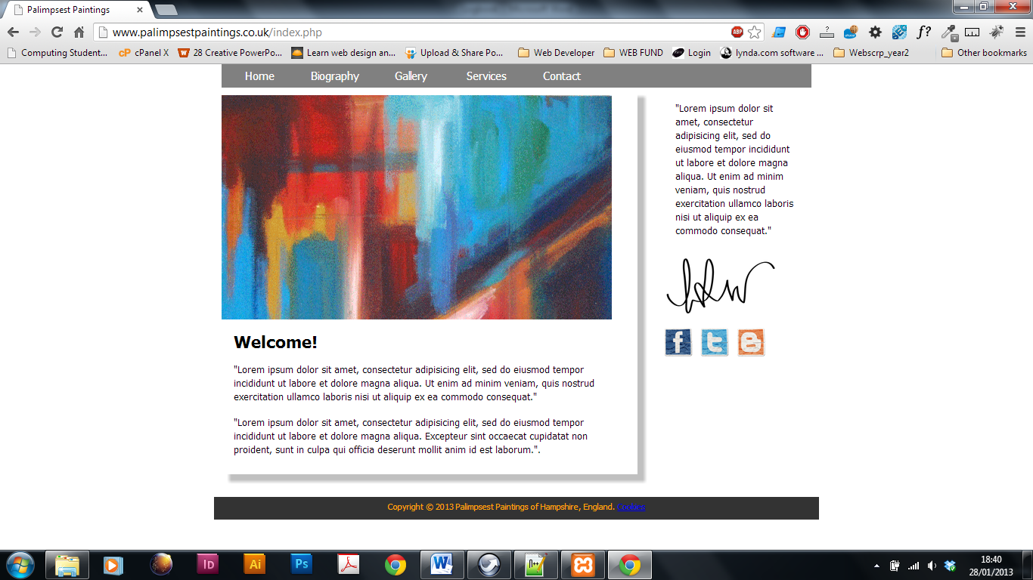

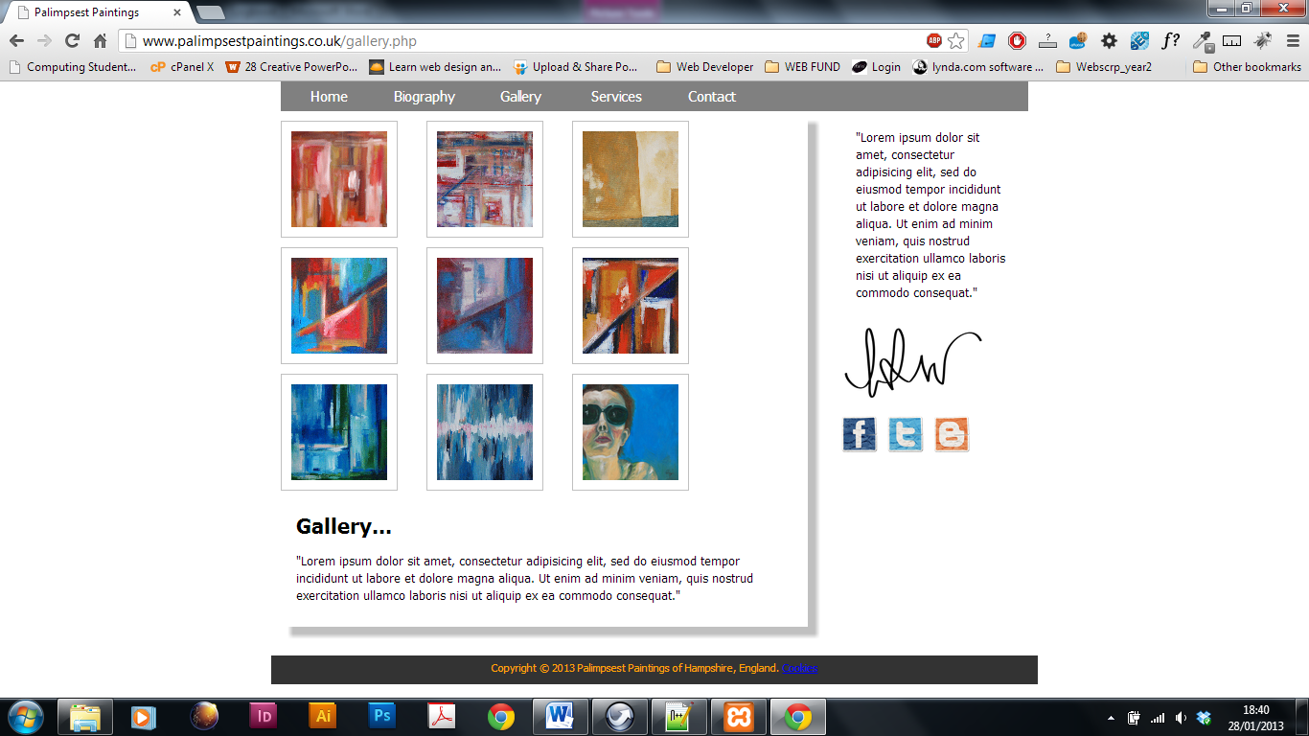

**Exercise 7.** When you have made some major progress on your site, test that it still validates. Correct any errors and put that all-important 'valid' icon in the footer of your site, linking through to validation services on W3schools.

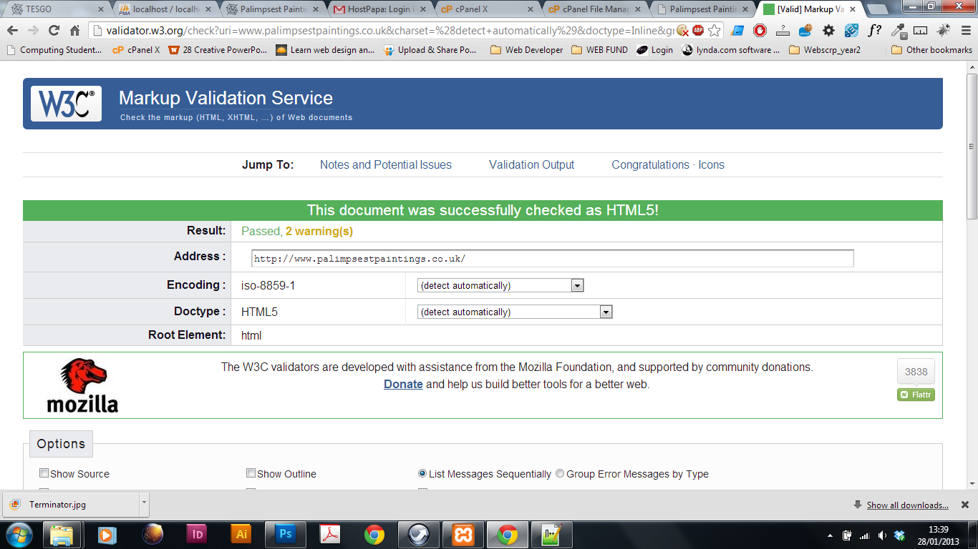

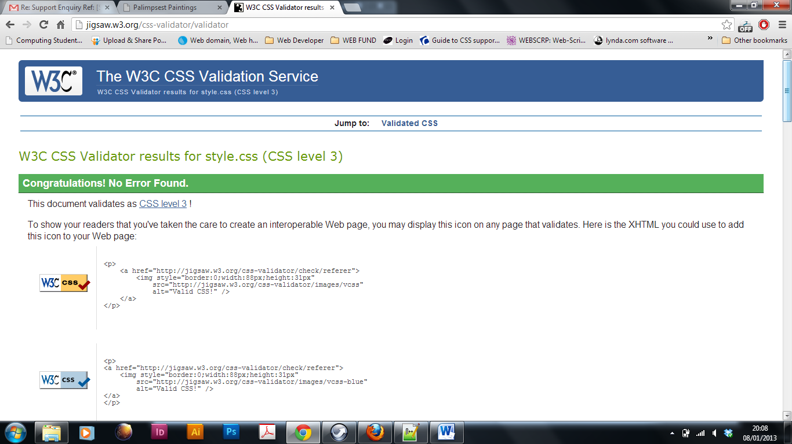

**Exercise 8.** Decide on a cookie policy for your website. What level of cookies does your site use? Will you use one of the freebies (links provided in your learning materials) or will you take the opportunity to gain extra credit and implement your own? Make short notes on all of these points, including *why* you would want to bother with a cookie policy.

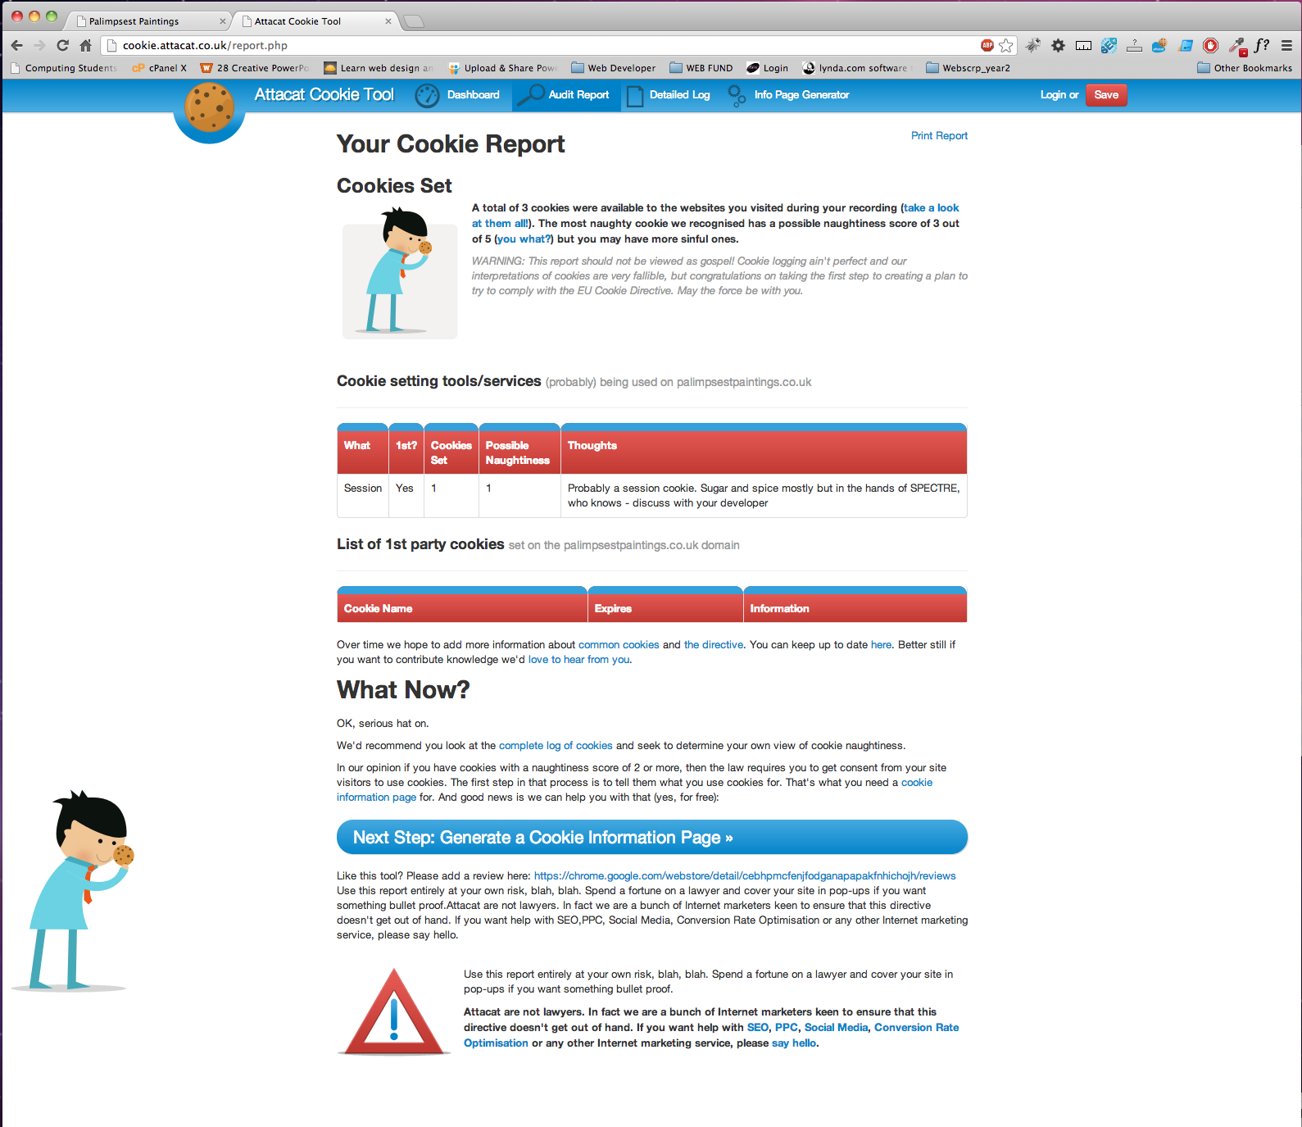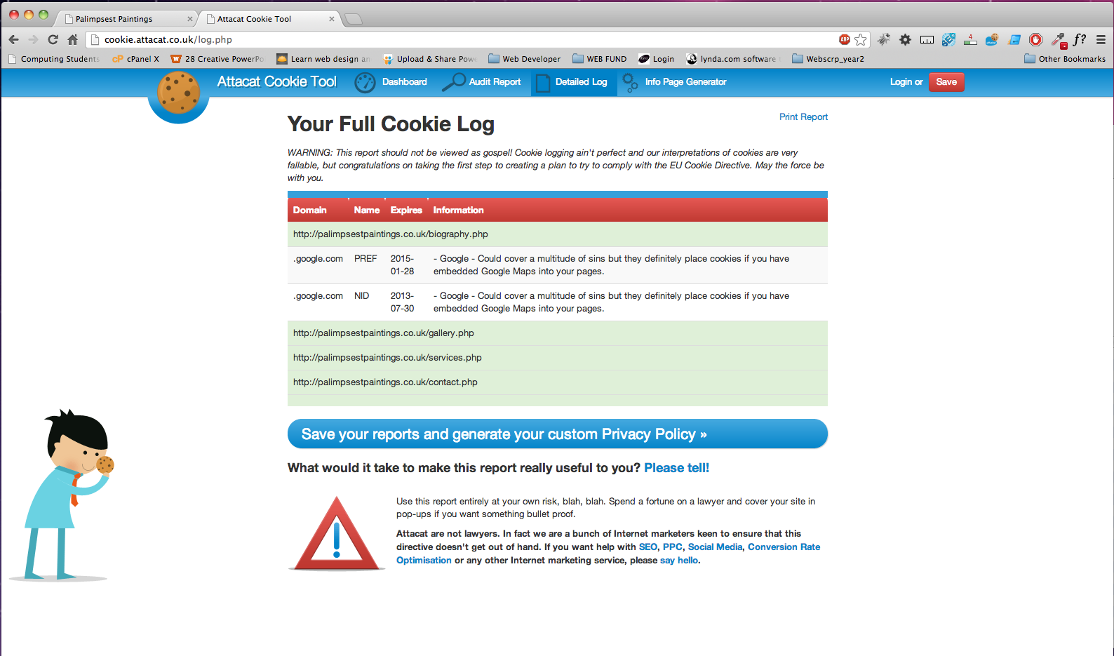

**Exercise 9.** Have you been incorporating SEO in your development stages? Go through your site and check it carefully, making notes in your log. Time to hit the social networking sites if you haven't already (Fb, Twitter, etc) and indexing sites (Qype, Brownbook, etc) to help your backlinks. Set up Google Analytics. List your search phrases that you are targeting. Where will they be used? (eg did you incorporate one in the domain name/page titles/anchor text/headings/site content/ … ) Make notes, explaining your decisions. Report on where the site is (in a general sense) in the listings for Google, Bing and Yahoo.

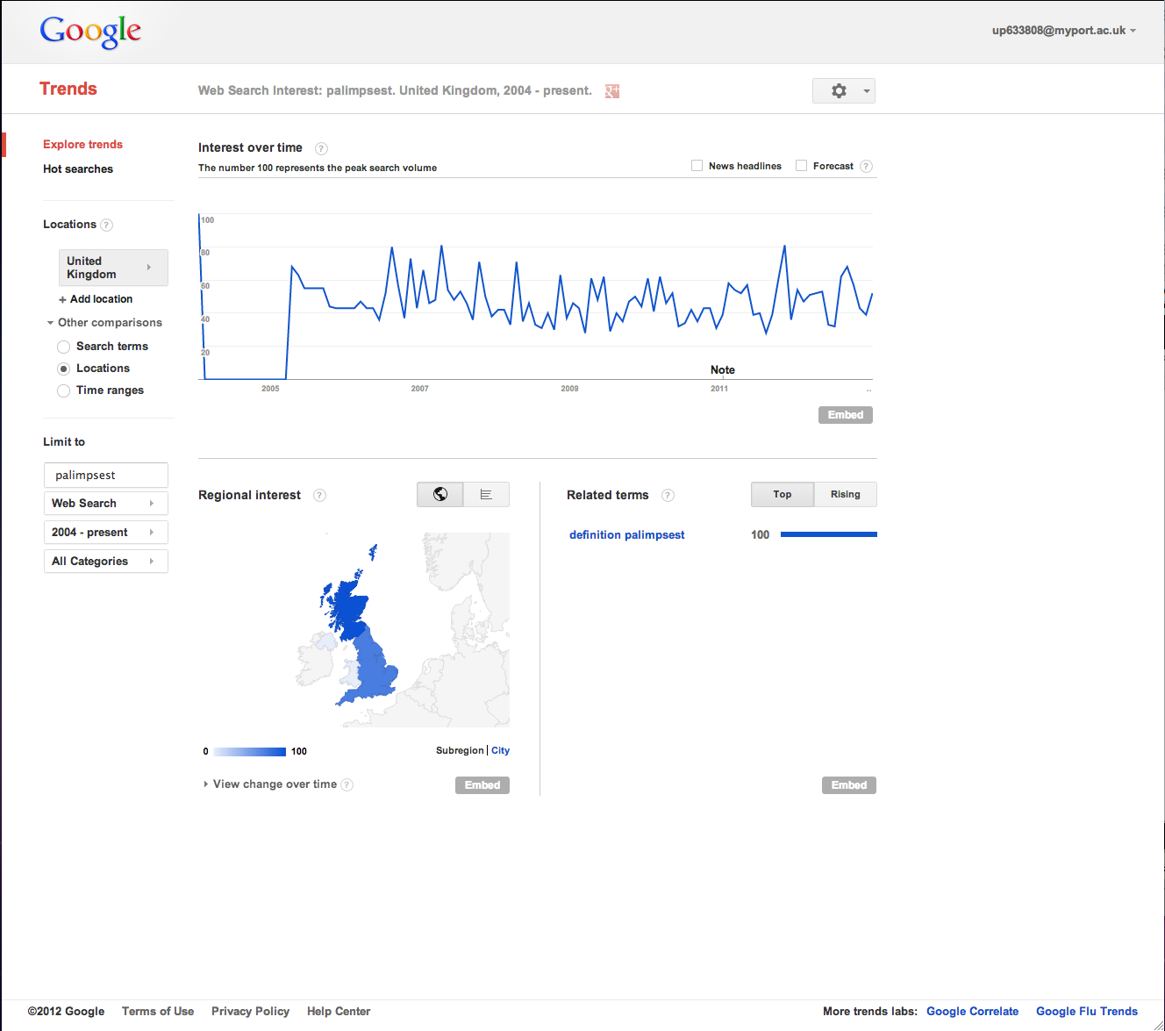

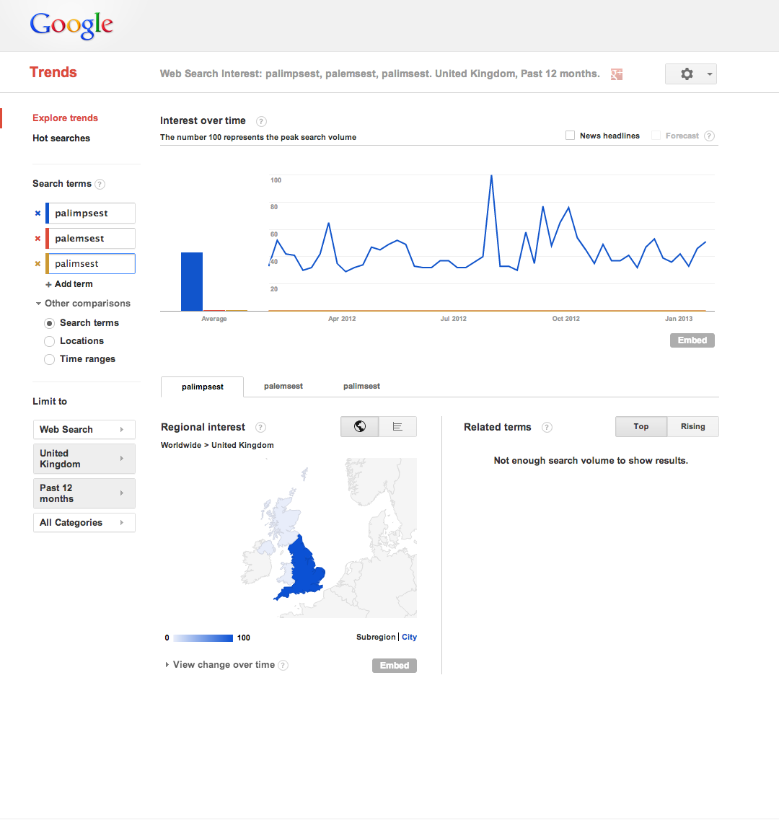

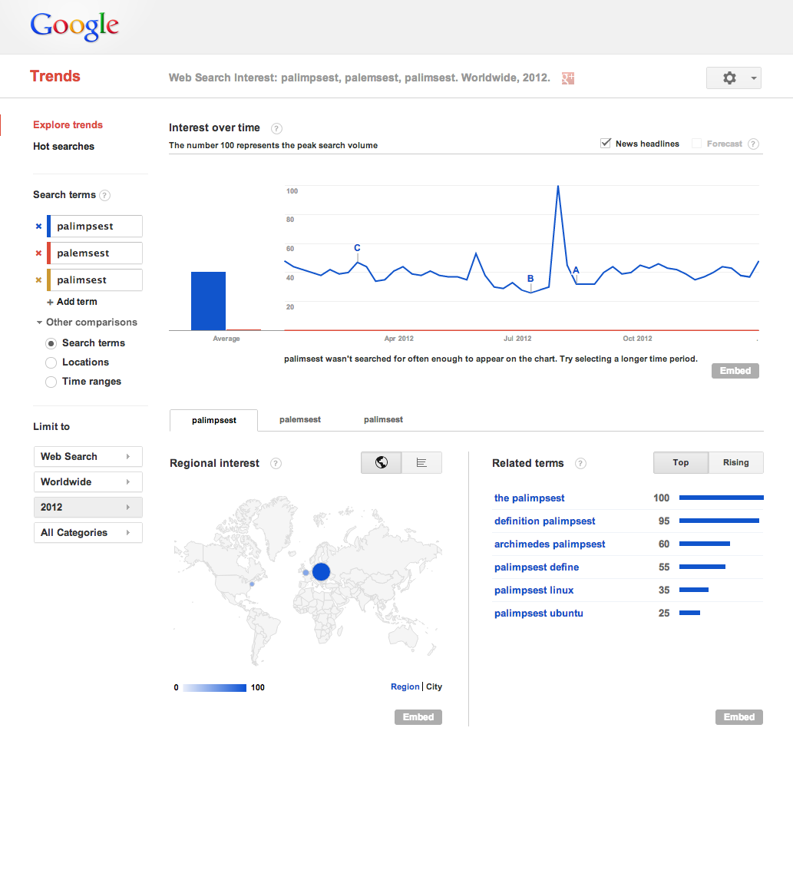

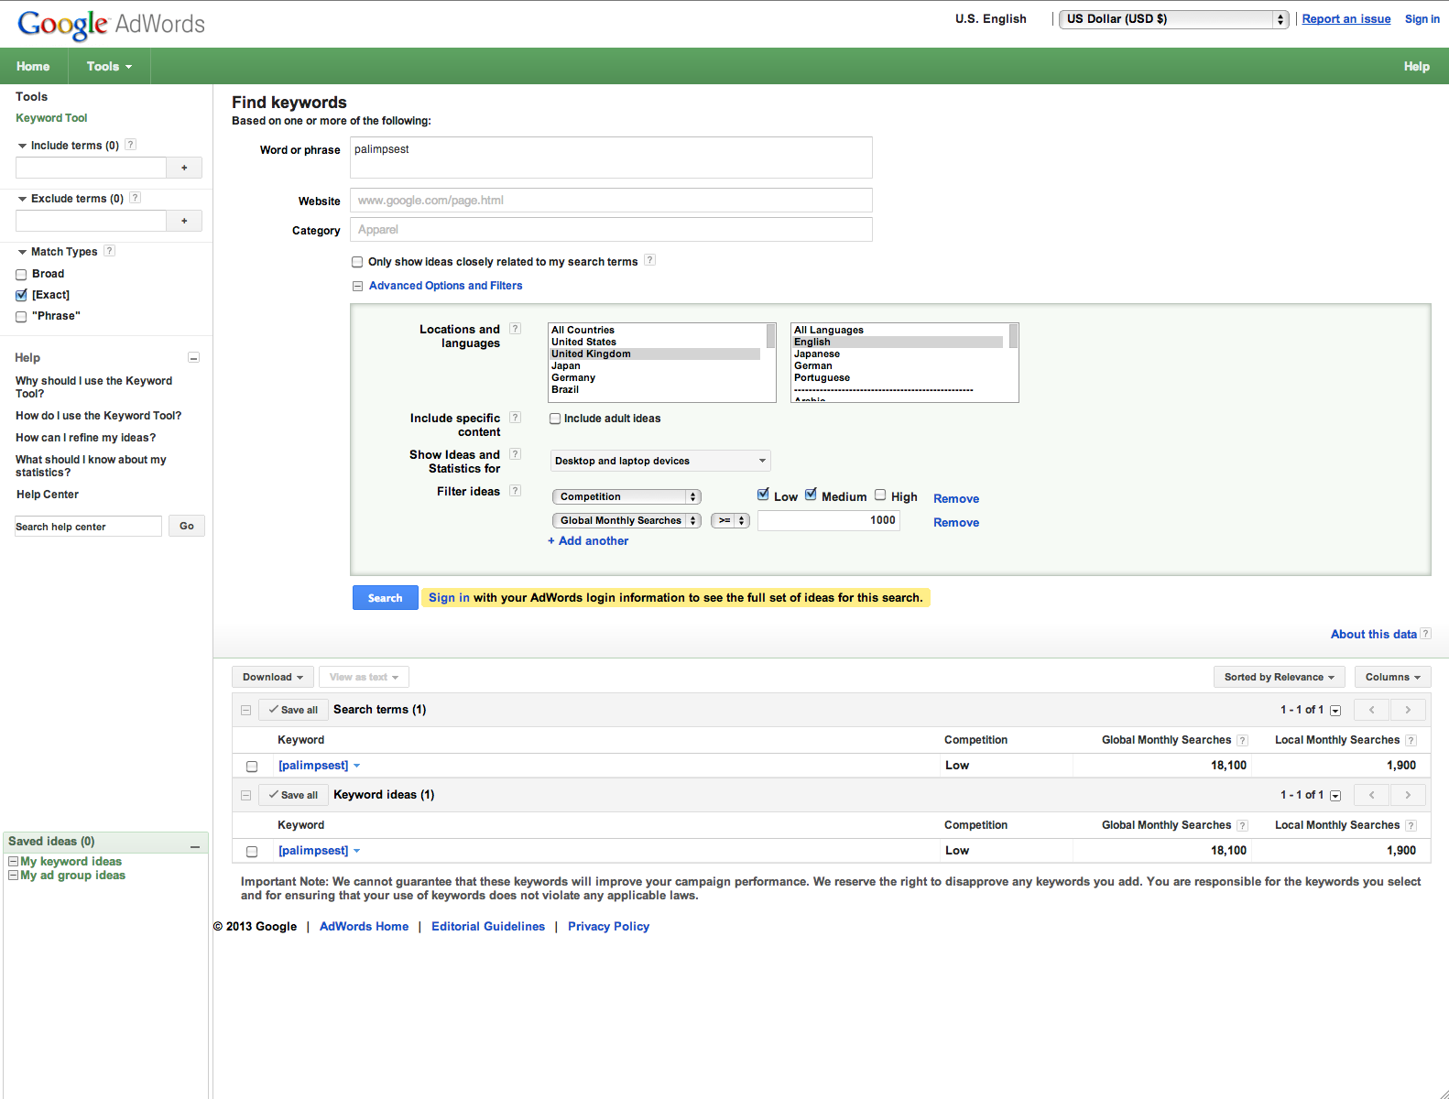

Keyword Competition Global Monthly Searches Local Monthly Searches (United Kingdom)

[distressed paintings] - 0 -

[giclee] 0.51 27100 2900

[abstract artists] 0.45 6600 1600

[acrylic painting] 0.42 12100 880

[abstract painting] 0.45 14800 880

[landscape art] 0.6 3600 590

[black and white art] 0.66 4400 480

[acrylic paintings] 0.63 4400 390

[painting gallery] 0.51 1300 73

[paintings of nature] 0.33 2400 46

[landscape oil painting] 0.61 1000 46

[colorful paintings] 0.46 1300 28

Keyword Competition Global Monthly Searches Local Monthly Searches (United Kingdom)

[distressed buildings paintings] - - -

[picasso paintings] 0.25 22200 2400

[watercolour painting] 0.64 5400 1900

[abstract artists] 0.45 6600 1600

[watercolour artists] 0.56 2400 1600

[acrylic painting] 0.42 12100 880

[landscape painting] 0.56 8100 880

[still life paintings] 0.26 4400 880

[abstract painting] 0.45 14800 880

[flower paintings] 0.45 6600 720

[oil paint] 0.55 5400 590

[chinese painting] 0.43 8100 480

[african paintings] 0.58 2400 390

[acrylic paintings] 0.63 4400 390

[pencil art] 0.33 6600 320

[indian paintings] 0.46 4400 260

[famous artists paintings] 0.32 1300 260

[water painting] 0.2 3600 260

[black and white paintings] 0.57 2400 210

[japanese paintings] 0.46 1900 170

[artist painting] 0.57 1000 140

[paint art] 0.39 1900 140

[painting gallery] 0.51 1300 73

[paintings of nature] 0.33 2400 46

[landscape oil painting] 0.61 1000 46

[scenery paintings] 0.25 1600 46

[mural paintings] 0.4 2400 28

[water color painting] 0.5 1300 12

Keyword Competition Global Monthly Searches Local Monthly Searches (United Kingdom)

[architecture paintings] 0.23 140 28

[art] 0.48 550000 40500

[architecture] 0.06 246000 22200

[aboriginal art] 0.31 40500 14800

[artists] 0.22 40500 12100

[famous artists] 0.1 40500 8100

[artist] 0.11 90500 6600

[african art] 0.33 18100 5400

[picasso paintings] 0.25 22200 2400

[landscape artists] 0.54 4400 2400

[impressionist artists] 0.24 5400 1600

[abstract artists] 0.45 6600 1600

[monet paintings] 0.4 9900 1600

[glass painting] 0.51 22200 1300

[painters online] 0.09 1300 1300

[acrylic painting] 0.42 12100 880

[oil painting techniques] 0.22 6600 880

[landscape painting] 0.56 8100 880

[still life paintings] 0.26 4400 880

[abstract painting] 0.45 14800 880

[flower paintings] 0.45 6600 720

[watercolor painting] 0.65 18100 720

[art exhibitions] 0.53 1600 720

[paintings i love] 0.18 2400 590

[landscape art] 0.6 3600 590

[oil paint] 0.55 5400 590

[black art] 0.47 12100 480

[modern painters] 0.43 2900 480

[impressionist art] 0.21 4400 480

[vintage art] 0.62 4400 480

[african paintings] 0.58 2400 390

[acrylic paintings] 0.63 4400 390

[online painting] 0.48 3600 320

[pencil art] 0.33 6600 320

[indian paintings] 0.46 4400 260

[oil painting for beginners] 0.32 2400 260

[famous artists paintings] 0.32 1300 260

[black and white paintings] 0.57 2400 210

[japanese paintings] 0.46 1900 170

[art works] 0.56 2900 170

[minimalist architecture] 0.04 1900 170

[watercolor artists] 0.65 4400 170

[classic paintings] 0.3 1300 140

[paintings of jesus] 0.58 1900 140

[artist painting] 0.57 1000 140

[paint art] 0.39 1900 140

[paintings of women] 0.28 2400 110

[modern painting] 0.59 2900 110

[tanjore paintings] 0.45 8100 110

[russian painters] 0.23 1000 91

[great paintings] 0.29 1300 91

[painting gallery] 0.51 1300 73

[best paintings] 0.19 1600 58

[paintings of nature] 0.33 2400 46

[landscape oil painting] 0.61 1000 46

[raja ravi varma paintings] 0.33 2900 46

[scenery paintings] 0.25 1600 46

[ravi varma paintings] 0.29 3600 46

[watercolor art] 0.55 1600 36

[mural paintings] 0.4 2400 28

Keyword Competition Global Monthly Searches Local Monthly Searches (United Kingdom)

[derelict paintings] - - -

[landscape artists] 0.54 4400 2400

[fine art america] 0.05 27100 2400

[art discount] 0.45 2400 1900

[abstract artists] 0.45 6600 1600

[acrylic painting] 0.42 12100 880

[discount art] 0.52 1300 880

[landscape painting] 0.56 8100 880

[still life paintings] 0.26 4400 880

[abstract painting] 0.45 14800 880

[graphic art] 0.25 8100 720

[flower paintings] 0.45 6600 720

[paintings i love] 0.18 2400 590

[landscape art] 0.6 3600 590

[oil paint] 0.55 5400 590

[black art] 0.47 12100 480

[african paintings] 0.58 2400 390

[acrylic paintings] 0.63 4400 390

[pencil art] 0.33 6600 320

[indian paintings] 0.46 4400 260

[tree paintings] 0.27 2400 210

[black and white paintings] 0.57 2400 210

[japanese paintings] 0.46 1900 170

[french paintings] 0.53 1000 170

[classic paintings] 0.3 1300 140

[artist painting] 0.57 1000 140

[digital art gallery] 0.39 1900 140

[paint art] 0.39 1900 140

[paintings of women] 0.28 2400 110

[modern painting] 0.59 2900 110

[great paintings] 0.29 1300 91

[realistic paintings] 0.09 1300 73

[madhubani paintings] 0.17 8100 73

[painting gallery] 0.51 1300 73

[best paintings] 0.19 1600 58

[paintings of nature] 0.33 2400 46

[landscape oil painting] 0.61 1000 46

[raja ravi varma paintings] 0.33 2900 46

[scenery paintings] 0.25 1600 46

[ravi varma paintings] 0.29 3600 46

[mural paintings] 0.4 2400 28

[paintings of india] 0.58 1000 16

Keyword Competition Global Monthly Searches Local Monthly Searches (United Kingdom)

[abstract paintings] 0.84 12100 720

[art] 0.48 550000 40500

[pop art] 0.09 246000 33100

[contemporary] 0.06 110000 18100

[aboriginal art] 0.31 40500 14800

[artists] 0.22 40500 12100

[painting] 0.36 110000 8100

[famous artists] 0.1 40500 8100

[artist] 0.11 90500 6600

[sculpture] 0.34 74000 5400

[african art] 0.33 18100 5400

[fine art] 0.43 27100 2900

[picasso paintings] 0.25 22200 2400

[arts] 0.05 40500 2400

[digital art] 0.28 27100 2400

[google art] 0.06 60500 1900

[abstract artists] 0.45 6600 1600

[art shop] 0.65 6600 1600

[abstract photography] 0.1 8100 1300

[acrylic painting] 0.42 12100 880

[oil painting techniques] 0.22 6600 880

[landscape painting] 0.56 8100 880

[still life paintings] 0.26 4400 880

[abstract painting] 0.45 14800 880

[flower paintings] 0.45 6600 720

[artworks] 0.52 9900 720

[watercolor painting] 0.65 18100 720

[landscape art] 0.6 3600 590

[oil paint] 0.55 5400 590

[what is abstract art] 0.08 2400 480

[black art] 0.47 12100 480

[modern painters] 0.43 2900 480

[impressionist art] 0.21 4400 480

[fine arts] 0.4 22200 480

[african paintings] 0.58 2400 390

[acrylic paintings] 0.63 4400 390

[famous abstract artists] 0.17 1900 390

[abstract images] 0.22 4400 320

[famous modern artists] 0.32 1300 260

[abstract art definition] 0.13 1900 260

[abstract artist] 0.09 1600 260

[indian paintings] 0.46 4400 260

[contemporary artist] 0.44 1900 260

[famous artists paintings] 0.32 1300 260

[what is contemporary art] 0.18 1600 210

[abstract landscape] 0.1 1000 210

[contemporary painters] 0.33 1300 210

[famous contemporary artists] 0.22 1300 210

[beautiful paintings] 0.19 4400 210

[modern artist] 0.54 1300 210

[abstract impressionism] 0.12 1300 170

[abstract painters] 0.42 1000 140

[paint art] 0.39 1900 140

[modern painting] 0.59 2900 110

[amazing paintings] 0.1 1900 110

[surreal paintings] 0.05 1000 110

[abstract photos] 0.26 1600 91

[nature paintings] 0.11 2900 91

[abstract painting techniques] 0.33 1000 91

[realistic paintings] 0.09 1300 73

[painting gallery] 0.51 1300 73

[abstract drawings] 0.11 1300 58

[paintings of nature] 0.33 2400 46

[landscape oil painting] 0.61 1000 46

[abstract painting ideas] 0.37 1300 36

[colorful paintings] 0.46 1300 28

Keyword Competition Global Monthly Searches Local Monthly Searches (United Kingdom)

[abandoned paintings] - 22 -

[famous artists] 0.1 40500 8100

[giclee] 0.51 27100 2900

[artists names] 0.22 4400 2900

[landscape artists] 0.54 4400 2400

[impressionist artists] 0.24 5400 1600

[abstract artists] 0.45 6600 1600

[acrylic painting] 0.42 12100 880

[landscape painting] 0.56 8100 880

[still life paintings] 0.26 4400 880

[abstract painting] 0.45 14800 880

[flower paintings] 0.45 6600 720

[daily painters] 0.09 4400 590

[paintings i love] 0.18 2400 590

[famous art] 0.07 6600 590

[landscape art] 0.6 3600 590

[oil paint] 0.55 5400 590

[impressionist painters] 0.15 6600 480

[modern painters] 0.43 2900 480

[figurative art] 0.44 1900 480

[famous artists names] 0.16 1900 390

[african paintings] 0.58 2400 390

[list of famous artists] 0.12 1900 390

[acrylic paintings] 0.63 4400 390

[last supper da vinci] 0.19 2900 390

[famous artwork] 0.1 5400 320

[still life art] 0.18 1600 320

[famous modern artists] 0.32 1300 260

[spanish painters] 0.2 1900 260

[abstract artist] 0.09 1600 260

[cubist paintings] 0.02 1300 260

[indian paintings] 0.46 4400 260

[italian art] 0.38 2900 260

[tree paintings] 0.27 2400 210

[black and white paintings] 0.57 2400 210

[butterfly paintings] 0.44 1600 210

[bird paintings] 0.63 1600 210

[contemporary painters] 0.33 1300 210

[famous contemporary artists] 0.22 1300 210

[diego rivera paintings] 0.28 5400 210

[japanese paintings] 0.46 1900 170

[leonardo da vinci art] 0.07 1600 170

[french paintings] 0.53 1000 170

[paintings of trees] 0.49 1300 140

[classic paintings] 0.3 1300 140

[artist painting] 0.57 1000 140

[leonardo da vinci artwork] 0.05 1900 140

[paint art] 0.39 1900 140

[famous paintings of women] 0.2 1300 140

[paintings of women] 0.28 2400 110

[modern painting] 0.59 2900 110

[fineart] 0.34 6600 110

[famous works of art] 0.12 1600 110

[leonardo da vinci pictures] 0.09 1000 91

[great paintings] 0.29 1300 91

[web art gallery] 0.38 1600 73

[realistic paintings] 0.09 1300 73

[painting gallery] 0.51 1300 73

[leonardo da vinci life] 0.16 1000 58

[best paintings] 0.19 1600 58

[famous artworks] 0.04 1600 46

[pictures of leonardo da vinci] 0.2 1000 46

[paintings of nature] 0.33 2400 46

[landscape oil painting] 0.61 1000 46

[world famous paintings] 0.29 1900 46

[raja ravi varma paintings] 0.33 2900 46

[scenery paintings] 0.25 1600 46

[mural paintings] 0.4 2400 28

[colorful paintings] 0.46 1300 28

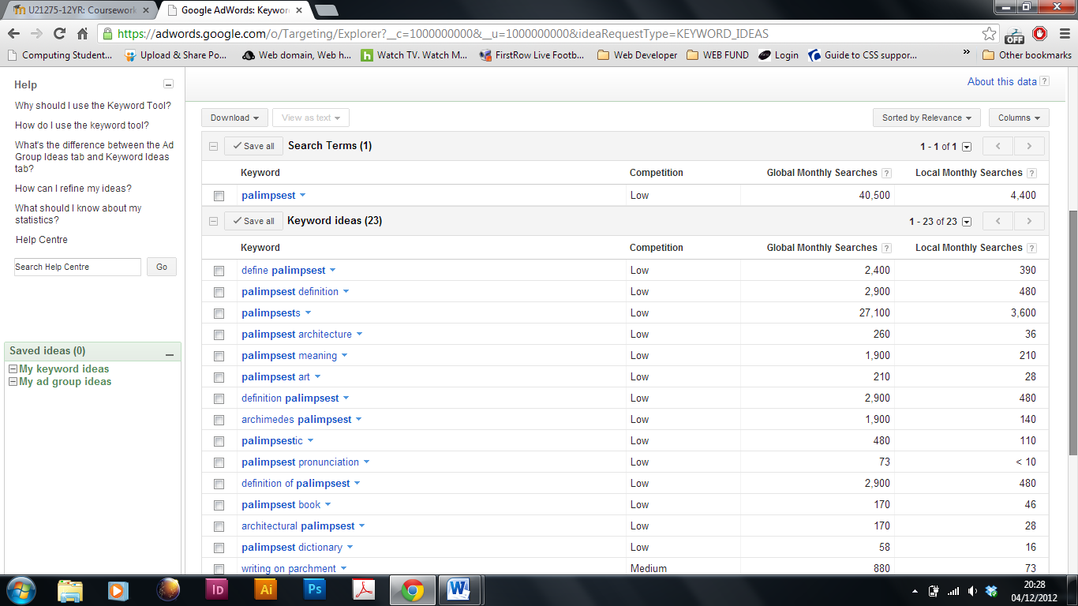

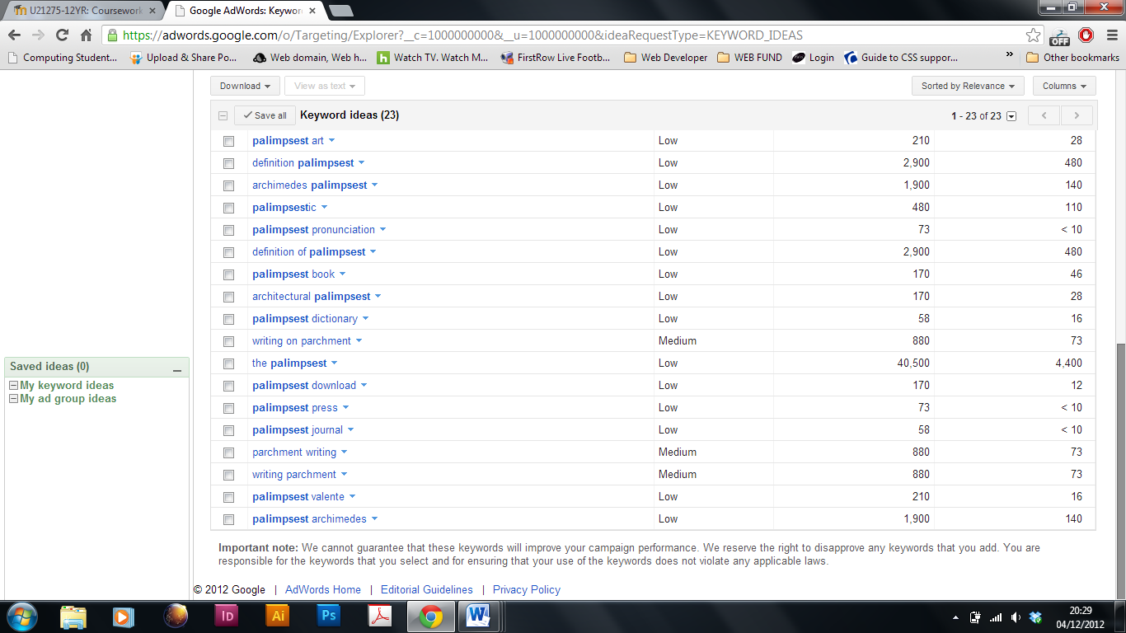

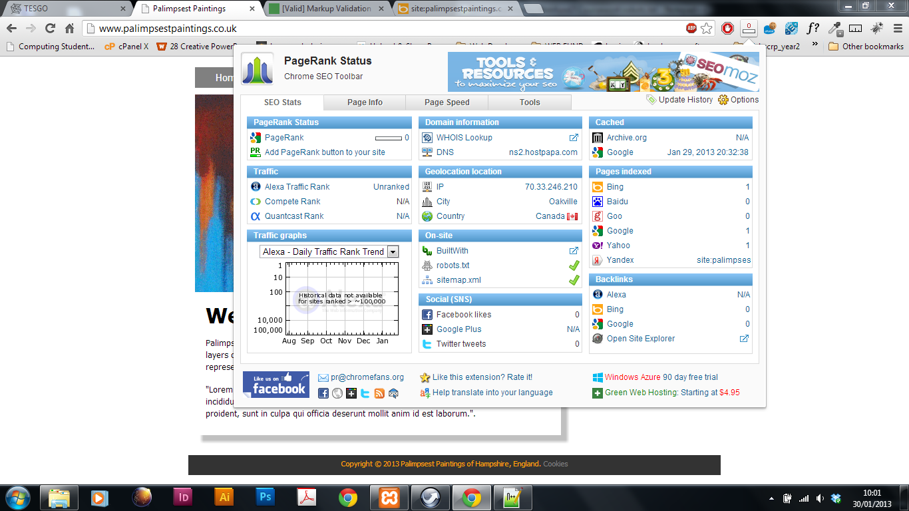

**Exercise 10.** Using the resources in *Essential tools for Webf.doc* create an xml sitemap and submit it to Google and the other main search engines. You can use automatic sitemap creation tools if you wish, but you will be expected to understand the entire process and explain the various parts of the xml file. Make short notes in your log. You will need to update this and upload/resubmit each time you make major changes. If using a framework such as Wordpress, etc., you will need to provide an alternative here or fully explain the sitemap that has been generated.

**XML Sitemap for palimpsespaintings.co.uk**

This XML file does not appear to have any style information associated with it.   
The document tree is shown below.

<urlset xmlns="http://www.sitemaps.org/schemas/sitemap/0.9"xmlns:  
xsi="http://www.w3.org/2001/XMLSchema-instance"xsi:schemaLocation="http://www.sitemaps.org/schemas/sitemap/0.9 http://www.sitemaps.org/schemas/sitemap/0.9/sitemap.xsd">

<url>

<loc>http://www.palimpsestpaintings.co.uk/</loc>

</url>

<url>

<loc>http://www.palimpsestpaintings.co.uk/index.php</loc>

</url>

<url>

<loc>http://www.palimpsestpaintings.co.uk/biography.php</loc>

</url>

<url>

<loc>http://www.palimpsestpaintings.co.uk/gallery.php</loc>

</url>

<url>

<loc>http://www.palimpsestpaintings.co.uk/services.php</loc>

</url>

<url>

<loc>http://www.palimpsestpaintings.co.uk/contact.php</loc>

</url>

<url>

<loc>http://www.palimpsestpaintings.co.uk/cookies.php</loc>

</url>

</urlset>

#### What is "XML sitemap"?

By placing a formatted xml file with site map on your webserver, you enable Search Engine crawlers (like **Google**) to find out what pages are present and which have recently changed, and to crawl your site accordingly. (http://www.brickmarketing.com/define-search-engine-crawler.htm)

#### What is "Change frequency"?

This value indicates how frequently the content at a particular URL is likely to change.

#### What is "Last Modified"?

The time the URL was last modified. This information allows crawlers to avoid recrawling documents that haven't changed.   
You can let the generator set this field from your server's response headers or to specify your own date and time.

#### What is "Priority"?

The priority of a particular URL relative to other pages on the same site. The value for this tag is a number between 0.0 and 1.0, where 0.0 identifies the lowest priority page(s) on your site and 1.0 identifies the highest priority page(s) on your site.   
The default priority of a page is 0.5.

**Ref:** [**http://www.xml-sitemaps.com/**](http://www.xml-sitemaps.com/)

///////////////////////////////////////////////////////////////////////////////////////////////////////

Internet Explorer 9 placing 1px border around logos on each page

////////////////////////////////////////////////////////////////////////////////////////////////////////

**Exercise 11.** Create a simple contact form that emails messages to your chosen email. Incorporate simple JavaScript to validate user input (at the very least you should have it checking that *something* is present in the important fields). You will need to prove that it works to obtain this signoff.

**Exercise 12.** Demonstrate your site to 2 peers (must be in WebF2). They should write short notes for you on usability (<http://www.webcredible.co.uk/user-friendly-resources/web-usability/usability-testing.shtml> ), accessibility, cosmetics/aesthetics of your site, functionality (eg orphan links, missing 404's, weird rollovers, bugs, etc), relevance (for example, is it obvious what the site is about, is the content relevant and so on). You should put their short reports in your logbook and comment on the points raised (do you agree with an issue? Do you intend doing something about it?). Reciprocate for others.

**Peer 1 –** Rob Lewis commented:

* Easy to read format
* The purpose of the site was clear
* Identified the target audience
* The design matches the original sketches
* Design incorporates a user-friendly navigation
* Works well across a variety of browsers
* Errors included non-descriptive alt tags  
  This relates to the Facebook and Twitter logos in the aside tag.  
  These have been corrected and validated
* The code is well structured and easy to read
* Enhancements suggested mobile optimisation  
  The client has not requested this, however there is a possibility to implement a responsive structure
* General comments include: Good design and well thought out

**Peer 1 –** Chris Kelly commented:

* Easy, nice to look at design format, navigation links could be bigger  
  I took on board the comment’s, however feel that the navigation suits well to the layout of the site. Regarding accessibility issues, the links are clear and change colour on hover which assists the identification of the navigation
* To display and sell artwork is the purpose of the site, clearly identified
* Target audience recognised as people interested in art
* No comment on the design reflection
* Single layer navigation makes it user-friendly
* Works fine across Chrome and Safari. Installs a horizontal scroll bar in Firefox and IE.  
  Increased the outer-wrapper by 2px to fix the Firefox and IE issue
* Errors include: Attribution for the validator link, 2 missing alt tags, horizontal scroll bar in certain browsers, IE shows a 1px border around graphics
* These errors have been corrected. Validation attribute clear, missing tags related to the social network images in the aside tag. The wrapper has been increased to overwrite the horizontal bar issue and the img tag has no decoration to solve the IE problem
* No comments, nice code layout, no hidden scripts  
  Commenting has been added
* Recommended enhancements, fix the errors and add content  
  Errors fixed and validates. Client has submitted the remainder of content and it has been implemented
* General comments suggest the content is required soon

**Exercise 13.** Write a short (200 - 400 words) report on your SEO success (or otherwise). Compare with the results from Ex. 9. What can you learn from Google Analytics? What worked? What didn't? What could you try to improve the site's SEO (eg would QR codes help? <http://www.qrcodestickers.org/about-qr-codes/qr-code-generator.html>)?

I have achieved some success regarding the sites SEO. The site is currently number one on Google regarding the search term ‘Palimpsest Paintings’ from about 282,000 results. However, I have a different outcome using the Bing search engine, where it does not feature in the top ten of 192,000 searches. Obviously, I will investigate this and try to improve on it’s organic position.

To reach this position within the Google search engine, I began by increasing the amount of keywords in my meta data. Using Google Analytics to research the terms that are most commonly searched for by online users regarding the sites sector. I also titled each image and gave relative information within their alt tags. Having external links to popular sites such as the ‘Tate Modern’ and social network sites have also been incorporated as well as local and national artists have helped the sites search engine position. Sitemaps have been uploaded enabling the search engines to intelligently crawl the site and see when the site was last updated plus its relation to the other URLs on the site. A robots.txt file has been uploaded to my host file manager. This prevents other crawlers and robots accessing other content from the site that is not public. It also helps for search engines to categorise and archive the site.

Regularly updating and uploading the sitemap would continue to benefit the sites page rankings. Another benefit to the site’s page ranking, would be to incorporate equivalent site forums, giving additional exposure to the business and increased external links. Using Google Analytics for demographic purposes would help to give information to where the majority of the sites users are located. This information could help me target artists in those areas and feature them on the site.

**Exercise 14.** **Time to show off!** Demonstrate your site to Ann, be prepared to point out the good, the bad and the ugly on your site. You will also be expected to answer questions, so make sure you understand and can *explain* absolutely anything to do with your site.

**Exercises 15 and 16.** Over the Easter break, write a short (250 - 500 words) report on accessibility, usability and protocols as the last entry in your logbook. Try to make this as relevant to your experience as possible. This should not be ripped from somewhere else, put it in your own words and reference your research sources.

**Accessibility**

Similar to public building legislation where amenities need to be accessible to those with disabilities, laws have been passed that require websites to be equally accessible for the disabled.

Screen readers are programs that read contents of websites mainly used by visually impaired people. Web developers can assist by writing descriptive code. For example giving images alt tags, that describe in short the image content. This short comment can be picked up by the screen reader and echoed out to the user.

Font sizes and the use of colour are considerations by a Web Designer. The restrictions they entail include corporate guidelines and branding controls. Yet these requirements must also cater for every user that the site is targeting. A lack of contrast can be a problem for a visually impaired or a colour blind person. Text is difficult to read where the contrast of a background is low (eg white text on a 30% black tint background). Equally, a high contrast page with a lot of text can be hard to read. A possible solution is to increase the text height between each line. Having the functionality where the user can alter the size of the text on a web page adds to the sites accessibility considerations.

The use of descriptive alt tags can be found within the palimpsestpaintings website. The site has been designed to attract the users eye, primarily to the artists paintings (this is achieved by using a white background and having the artwork as large as possible). Though, the main focus is drawn towards the artwork the contrast between the text and its surrounding colours is easily read and deliberately kept to short line lengths that help the user to follow.

**Usability**

Palimpsestpaintings.co.uk is a site for a local artist who requires current and potential clients to access information regarding the company as well as promoting herself as an artist in Hampshire. The site has been designed with the artwork being the main focus. It is part portfolio, part descriptive of the artist and other UK artists including current art events.

Navigation is clear and easily accessible at the top of each page. The body section of each page is descriptive of the page title, whilst the aside is informative relating to events, user comments, news and social network links. Within the pages, links can be seen in red which stands out clear to the body text (obviously noticeable for the user that a link is present).

Within the footer on each page are contact details plus the companies’ cookie policy informing the user of the sites use of visitors information.

**Protocols**

Palimpsestpaintings.co.uk uses Hypertext Transfer Protocol (HTTP). It is the foundation of data communication for the World Wide Web (WW).

**References**

# Berners-Lee, T. (1996) Hypertext Transfer Protocol -- HTTP/1.[online] Available at http://tools.ietf.org/html/rfc1945 [Accessed 21 April 2013]

**Duckett, J (2011)** *HTML&CSS Design and Build Websites.* 1st Ed.   
Indiana, US: John Wiley & Sons Inc.  
“Screen Readers” p.7  
“Contrast” p.253

